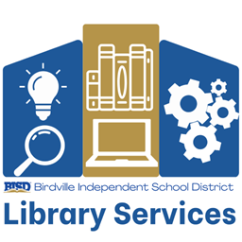

Texas Star Reading List
2024- 2025
Haltom Middle School

- Alexander, Kwame – The Door of No Return
- Barry, Michelle A. – Plotting the Stars: Moongarden
- Bayron, Kalynn– The Vanquishers
- Bow, Erin – Simon Sort of Says
- Carvalho, Rebecca – Salt and Sugar
- Day, Christine – We Still Belong
- Everett, Sarah – The Probability of Everything
- Fawcett, Heather – The Grace of Wild Things
- Feldman, Jacquetta Nammar – The Puttermans Are in the House
- Glaser, Karina Yan – A Duet for Home
- Greenwald, Tommy – Dinged
- Hardinge, Frances – Unraveller
- Healy, Christopher – No One Leaves the Castle
- Hiaasen, Carl – Wrecker
- Horwitz, Sarah Jean – The Demon Sword Asperides
- Landers, Melissa – Lumara
- Lewis, Kayvion – Thieves’ Gambit
- López, Diana – Los Monstruos: Felice and the Wailing Woman
- Morris, Chad, and Shelly Brown – Virtually Me
- Oh, Ellen (editor) – You Are Here: Connecting Flights
- Perry, Adam – Ghosts Come Rising
- Pla, Sally J. – The Fire, the Water, and Maudie McGinn
- Salazar, Aida – A Seed in the Sun
- Santat, Dan – A First Time for Everything
- Schmidt, Gary D. – The Labors of Hercules Beal
- Siddiqui, Maleeha – Bhai for Now
- Swinarski, Claire – What Happened to Rachel Riley?
- Warga, Jasmine – A Rover’s Story
- Waters, Charles & Traci Sorell – Mascot
- Wein, Elizabeth – Stateless

The Texas Star Reading list is a reading incentive program for middle school students in BISD. We encourage self-selection, allowing students to choose books on the list which align with their tastes and interests.

