**Recruitment, Application, and Selection of Students for**

**The Collegiate Academy of Birdville**

**Recruitment and Application:**

Benchmark 3 in the Early College High School Blueprint states:

*“The Early College High School (ECHS) shall target and enroll historically underserved students. The campus must enable students who are at-risk of dropping out or those who wish to accelerate completion of high school to combine high school courses and college-level courses.*

*Enrollment decisions shall not be based on state assessment scores, discipline history, teacher recommendations, parent or student essays, minimum grade point average (GPA), or other criteria that create barriers for student enrollment.”*

Under *Recruitment and Enrollment Policies* it also states:

*“The ECHS shall be open enrollment for all students and shall identify, recruit, and enroll subpopulations that are historically underrepresented in college courses. The ECHS shall coordinate activities with feeder middle school(s) and higher education partner(s) to participate in recruitment activities.”*

Beginning in November, campus representatives make presentations to all 8th grade students in the district through College and Career classes (seven campuses, once each semester, 14 visits) and students have an opportunity to apply at the end of presentation by filling out a simple form that provides us with their name, email address, and their BISD ID number. It is a branching application, so if a student applies from outside the district the applicant fills out all the information that we will pull from Focus for BISD students.

In December, three Parent Information Nights are held, one at each high school in the evening. The link to open application is posted on district and campus websites, and the Communications Department sends a mass email to all families of 8th grade students with the website and application links. Applications close in mid-February.

Immediately after applications close, invitations are sent to all applicants to attend one of two Interview Nights, during which students and parents interview current students and teachers to answer any questions they may have and clarify their understanding of the program. At the end of these events parents and students are asked to sign the Parent-Teacher-Student Agreement that includes their commitment to stay in the program for at least one full year. They may take the agreement home, but must return it signed to the school by a specified date at the end of February. Only students who attend the Interview Night and sign the Agreement are entered into the lottery pool.

**Selection – The Weighted Lottery**

Under Section 3.4 of Benchmark 3 – Lottery System – the Blueprint states:

*“For any ECHS at capacity, the ECHS shall use either a performance-blind, open-access lottery system that encourages and considers applications from all students (all students have an equal opportunity for acceptance, regardless of background or academic performance) or a weighted lottery that favors students who are historically underrepresented students for the ECHS. Districts are encouraged to standardize lottery practices across campuses implementing the College and Career Readiness School Models. “*

The TEA Blueprint for Early College High Schools sets targets for representation in incoming cohorts each year as their Access Outcomes-Based Measures (OBMs). The table below is taken from the Blueprint. The only targets that are required for renewal as an ECHS are those for At-Risk Students and Economically Disadvantaged Students. To be Designated with Distinction a campus must also consider the targets for Emergent Bilingual Students and Students with Disabilities (SPED, 504).

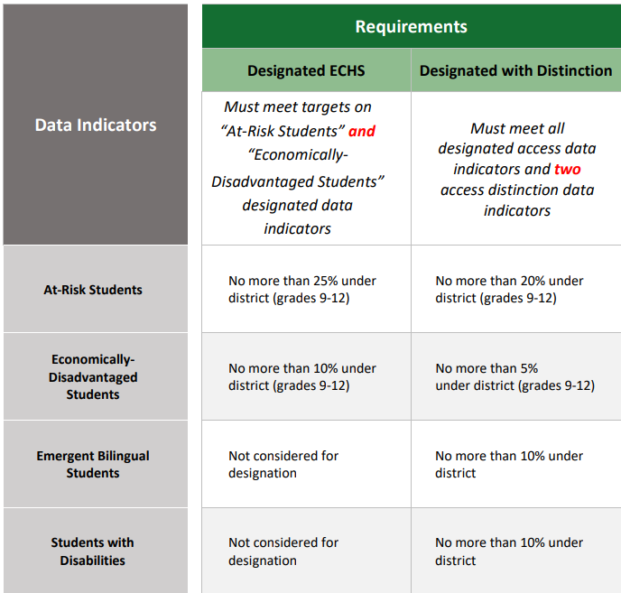

Previous iterations of the Blueprint and the OMBs set targets for subpopulations that are historically underrepresented in college courses including “… African American, Hispanic, (and) Native American” and those targets have been part of our weighted lottery system. The Access OMB for those subpops was “no more than 5% under the district”. These subpops are not identified in the 20-21 Blueprint, but we have maintained these goals to insure our student population accurately reflects the district population. We have also found it necessary to weight males in order to maintain proportional representation because the applicant pool has been disproportionately female in each prior applicant pool.

BISD Enterprise Systems pulls the data on the applicants and runs the demographics of the applicant pool. That is compared to the state snap-shot district demographics for at-risk, socioeconomically disadvantaged, emergent bilingual, racial sub-pops, male/female, and 504/SPED. Groups that are not representative of the district have their weighting adjusted until the runs with a sample population (not the applicant pool, but a pool of actual students pulled to reflect the applicant demographics) yields the desired results as specified by the OBMs. In early March the program is run on the applicant pool, and the top 70 receive invitations to join. The remainder are placed on a wait list in the order pulled. If we have more than 10 students who leave the program, students from the wait list are invited in waitlist order to join the CAB in their sophomore year so that we can serve the maximum number of students allowed.