Birdville ISD PLCs: Planning for Learning Protocol
REFLECTION
Curriculum | Aligned Resources/Materials | Students
Assessment | 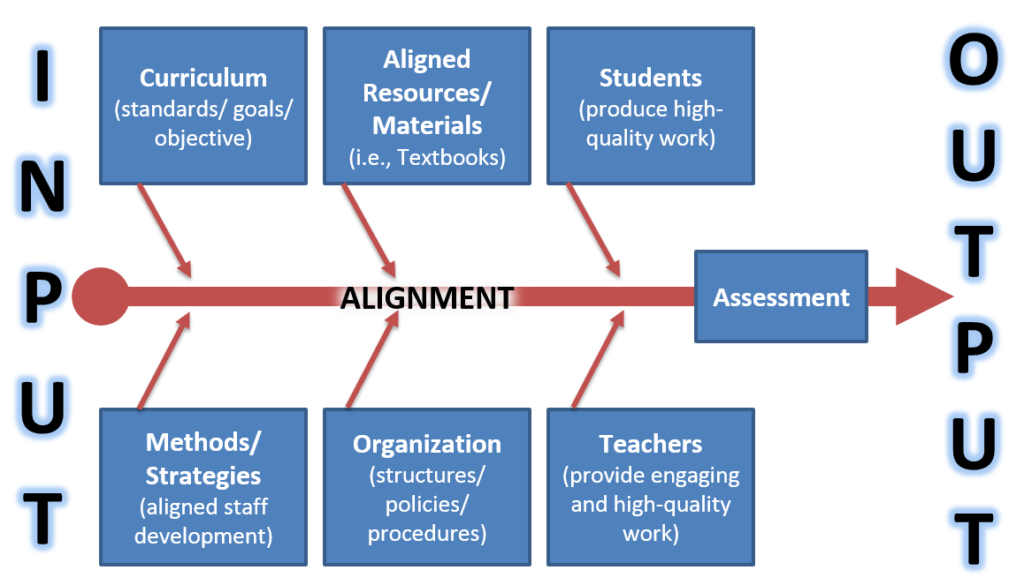 | What factors had the least/most favorable impact on the output?
Methods/Strategies | Organization | Teachers

