Birdville ISD PLCs: Planning for Learning Protocol

**THE LESSON**

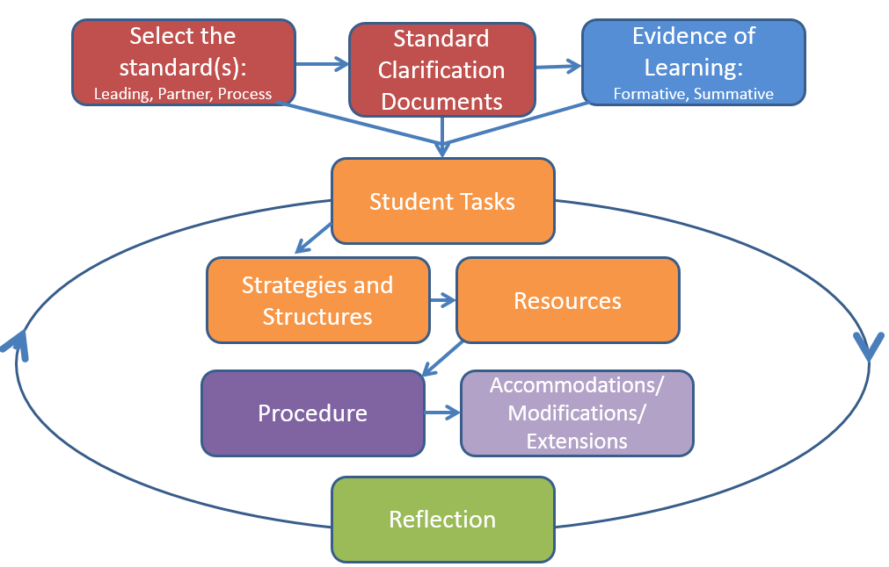

|  |  |  |  |
| --- | --- | --- | --- |
| **Select the Standard:** **Leading Standard** What standard is the target of learning? (leading standard) | | **Standard Clarification Documents:**  Cognitive rigor:  Content:  Context:  Sample Assessment(s): | |
| **Select the Standard(s): Partners and Process:** Are there any TEKS that partner with this standard? WHY would the partner standard(s) support student mastery of the leading standard?  What process skill(s) are necessary for the student to be able to master the standard(s)? | | **Standard Clarification Documents:**  Cognitive rigor:  Content:  Context:  Sample Assessment(s): | |
| **Evidence of Learning:**  What evidence will you collect in order to know if students have mastered the lesson standards?  How will you assess the evidence (rubric, multiple-choice, observation, etc.)?  What formative assessments can be used throughout the lesson cycle to monitor student progress?  What summative assessment will be used to evaluate learning? | | | |
| **Student Tasks: TASK = PERFORMANCE**  What do students need to DO in order to engage in the content, context, and cognitive rigor of the lesson standards? Examine the lesson standards and clarification documents to synthesize the overall learning represented in this lesson.  What specific tasks will students work through during this lesson? How do these tasks cause students to operate at the appropriate cognitive level within the content and context of the lesson standards?  What would an exemplar student task look like? How would students demonstrate mastery of the lesson standards through the task(s)? | | | |
| **Strategies and Structures:**  What strategies can I use to cause my students to engage in the content, context, and rigor of the standard(s)?  What is the purpose of each strategy I choose and how does it align to the standard(s)?  How can I use different groupings to structure learning?  What is the purpose of each structure I choose and how does it align to the standard(s)?  How will the strategies and structures utilized in the lesson support students’ abilities to perform at high levels on the designed task(s)? | | | |
| **Resources:**  What resources will my students need?  How do these resources align to the intent of the standards? | | | |
| **Procedure:**  What activities and processes will I use to ensure that what I have planned in terms of grouping and strategies occurs in an efficient and effective manner? | | | |
| **Accommodations/Modifications/Extensions:**  How can I plan for differentiation according to the varied needs of my students? | | | |
| **High**  Extend the learning | **On-Level**  Master the learning | | **Low**  Accommodate and modify for learning |
| **Notes/Reflections:**  What will I do if students don’t get it? What other strategies could help my students?  Do I need to re-teach (whole group, certain students)? How will I re-teach and why? | | | |