**WriteSource Teacher Quick Start SetUp**

1. You have been set up in the WriteSource system and a class has been created for you. To login, simply go to ws.hmhpub.com and enter your username and password. If you haven’t registered yet or don’t remember your login information, enter your username (always your e-mail address) and click on “Forgot password or username”.

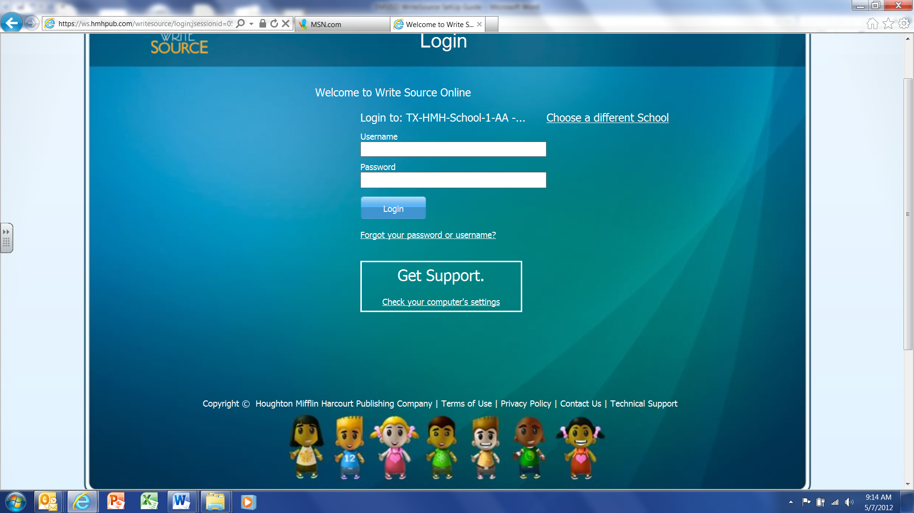

1. **You will be prompted to enter your e-mail address and a password reset e-mail will be sent to you (if you have not been set up in the system yet, you will get a message letting you know). Click on the Password Reset Link contained in the e-mail:**

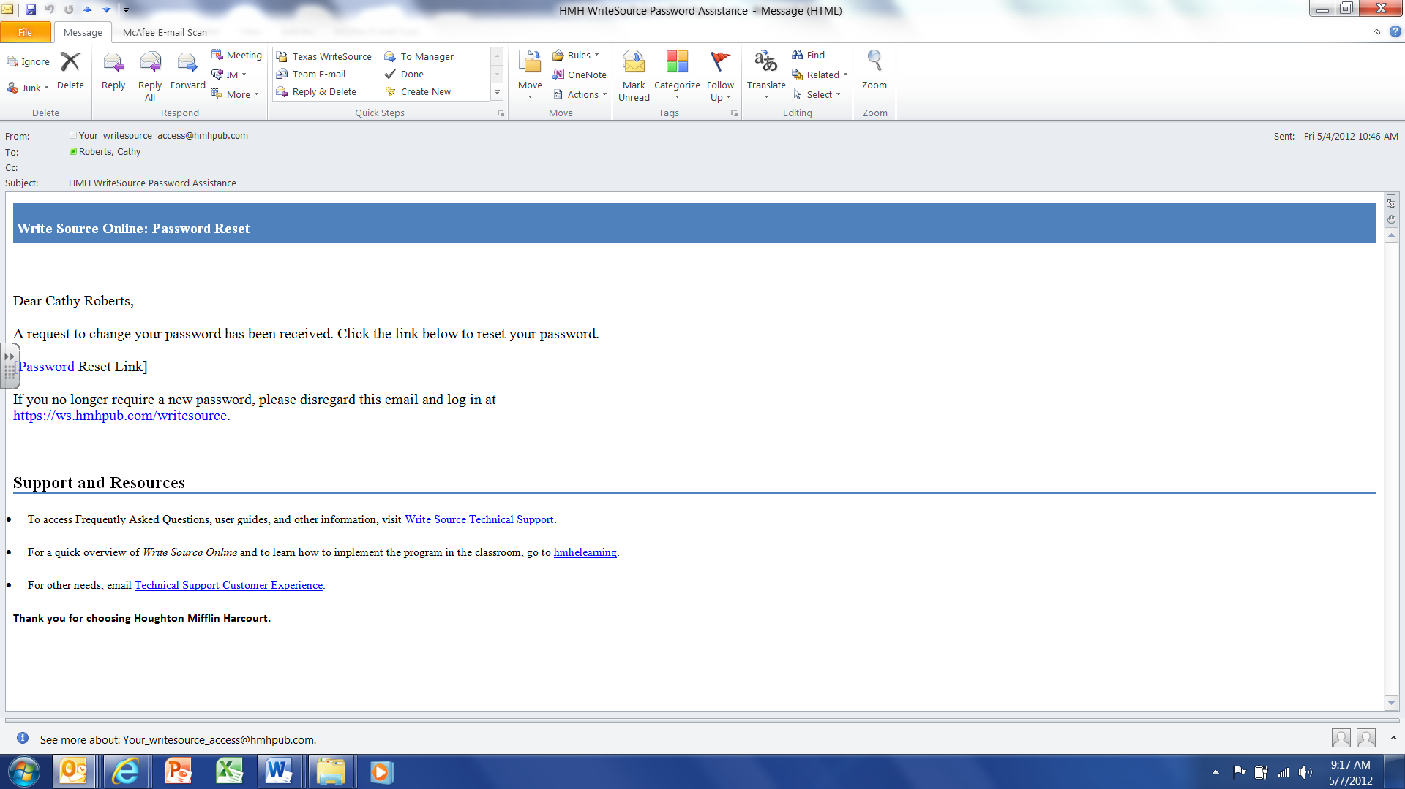

|  |  |  |  |  |  |
| --- | --- | --- | --- | --- | --- |
| **To Add Students:** |  |  |  |  |  |
| |  | | --- | | 1. Click on **Manage Class** from the top of the Teacher Dashboard: | |  |  |  |  |  |
|  |  |  |  |  |  |
|  |  |  |  |  |  |
|  |  |  |  |  |  |
|  |  |  |  |  |  |
|  |  |  |  |  |  |
|  |  |  |  |  |  |
|  |  |  |  |  |  |

1. Click on the **Students** tab from the Class Management Screen:

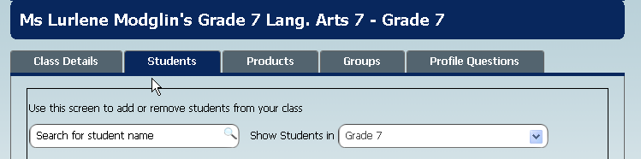

|  |  |
| --- | --- |
|  |  |

1. Find and select the new students from the available students listed on the left. Click the arrow button to move the students into the class list. Click **Save and Next** :

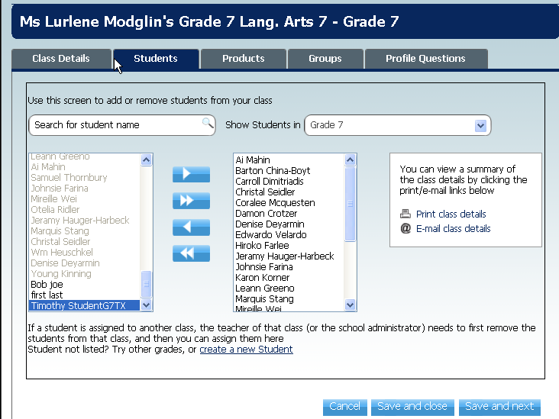

NOTE: to select more than one student, press and hold the **Shift** or **Ctrl** key, and then click the names. The **Shift** key selects the students in sequential order. The **Ctrl** key allows you to select students in non-sequential order.

**Allocating Products**

1. Fromthe **Products** tab, click the box in front of “All Teacher Products”(English, Spanish or both) and “All Student Products”. Click “Save and Next” to add groups, or “Save and Close” to go back to dashboard.

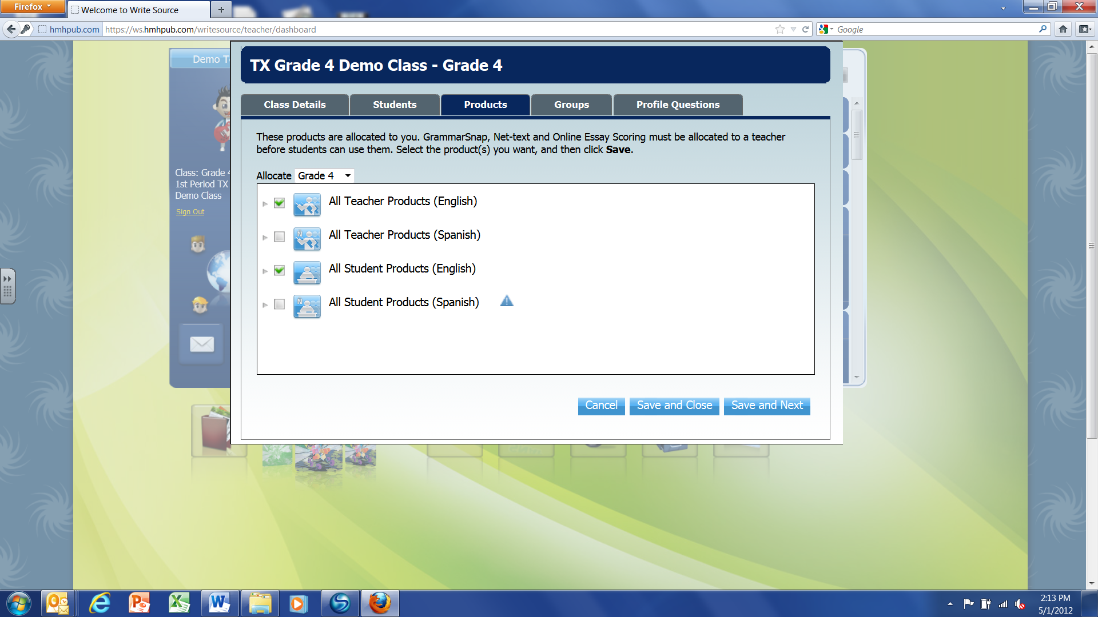

**NOTE: if you get a solid green box when you click instead of a green check mark, expand the list (click on small gray arrow) to see if some products have run out of licenses then contact your WriteSource District or School Administrator.**

1. To allocate products to another class, click on the **Change** link under your avatar on the landing page to choose the next class. Add students and products following the above steps. If you do not see the “change” link (in yellow under avatar), you only have one class set up in the system.

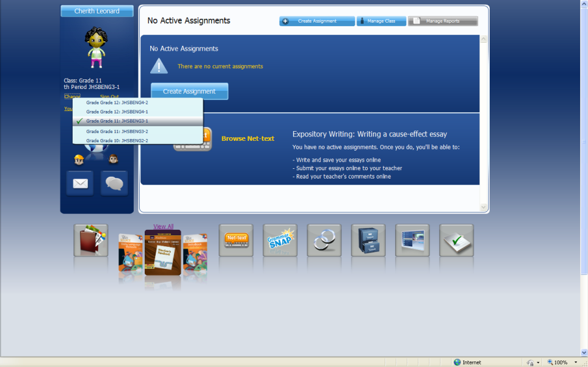

**NOTE:** The District/School Administrator must set up (name) your classes before you will have access to Texas WriteSource.