Cell Cycle, Mitosis, & Cancer Review
Due Date: _________________

Using the labeled Cell Cycle diagram to the right do the following:  Left column: place the corresponding letter for the correct stage  Right column: Complete the description of the stage in the |  | 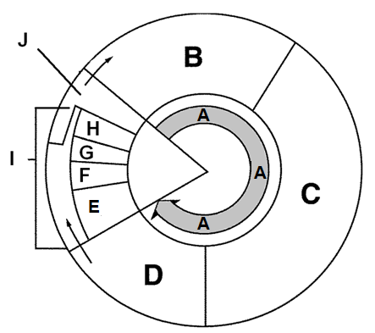
- A | ____________________: Consists of G₁, S and G₂ phases in the Cell Cycle.
- ___ | Cytokinesis – division of the cytoplasm resulting in two identical d_______________ cells.
- ___ | G₁ – growth phase: Makes organelles and proteins needed for replication of DNA. Also contains a G₁ checkpoint. If everything is correct, cell will proceed to S phase.
- ___ | S phase: DNA is replicated or synthesized.
- D | G₂ - growth phase: Cell gets ready to undergo M_____________. Also contains a G₂ checkpoint. If DNA replication is correct, checkpoint allows cell to enter M phase.
- ___ | Prophase: chromatin condenses to become chromatin, nuclear envelopes breaks down, and centrioles migrate to opposite poles in animal cells. Nucleolus disappears.
- ___ | M____________: sister chromatids line up along the metaphase plate in the middle. Spindle apparatus attaches at the centromere of the chromosomes.
- G | A______________: sister chromatids separate and move to opposite sides of the cell. The s___________ a______________ pulls them apart. This phase ends when the chromatids stop moving.
- ___ | Telophase: two nuclear envelopes begin reforming. Chromatids relax, uncoil & are now chromatin. Cytokinesis is occurring during Telophase but it is NOT considered a part of mitosis because it does not involve the nucleus of the cell. In plant cells, a cell plate begins to form while a c_____________ f_____________ is visible in animal cells.
- ___ | Mitosis: division of a cell’s nucleus. Occurs in this order: prophase, _________________, _______________, and telophase.

Label the phases of Mitosis below:
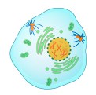 | 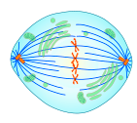 | 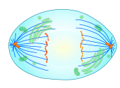 | 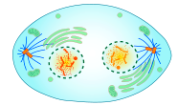 | 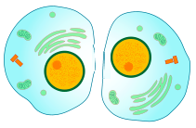

Complete the table by checking the correct column for each statement.
Statement | Interphase | Mitosis
- Cell growth occurs
- Nuclear division occurs
- Chromosomes are finishing moving into separate daughter cells.
- Chromosomes are duplicated
- DNA synthesis occurs
- Where cells spend most of their life
- Mitochondria and other organelles are made.

Use the following illustrations for questions 23 - 32
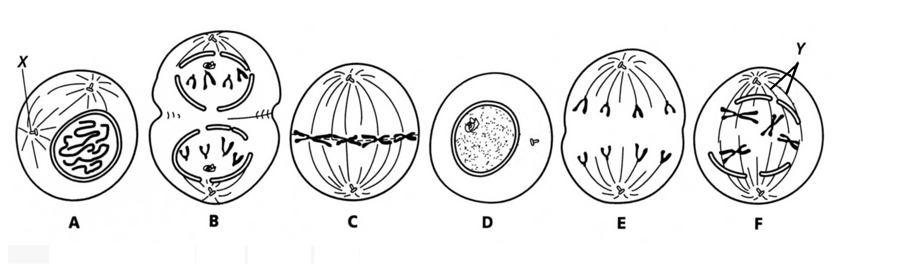
- In cell A, what is the structure labeled X? ___________________
- In cell F, what is the structure labeled Y? __________________
- Which cell is not in a phase of mitosis? ______________________
- New nuclear membranes are forming in B. What is this phase called? _____________________
- Sequence the six diagrams in chronological order from first to last. ____, ____, ____, ____, ____, ____
- Chromosomes move to the middle of the cell during? __________________________________________________
- When do the sister chromatids separate? _____________________________________________________________
- During which phase do chromosomes first become visible? ______________________________________________
- During which phase does the cleavage furrow start forming on animal cells? _________________________________
- If a cell has 46 chromosomes, how many chromosomes will each daughter cell have after mitosis? _____________
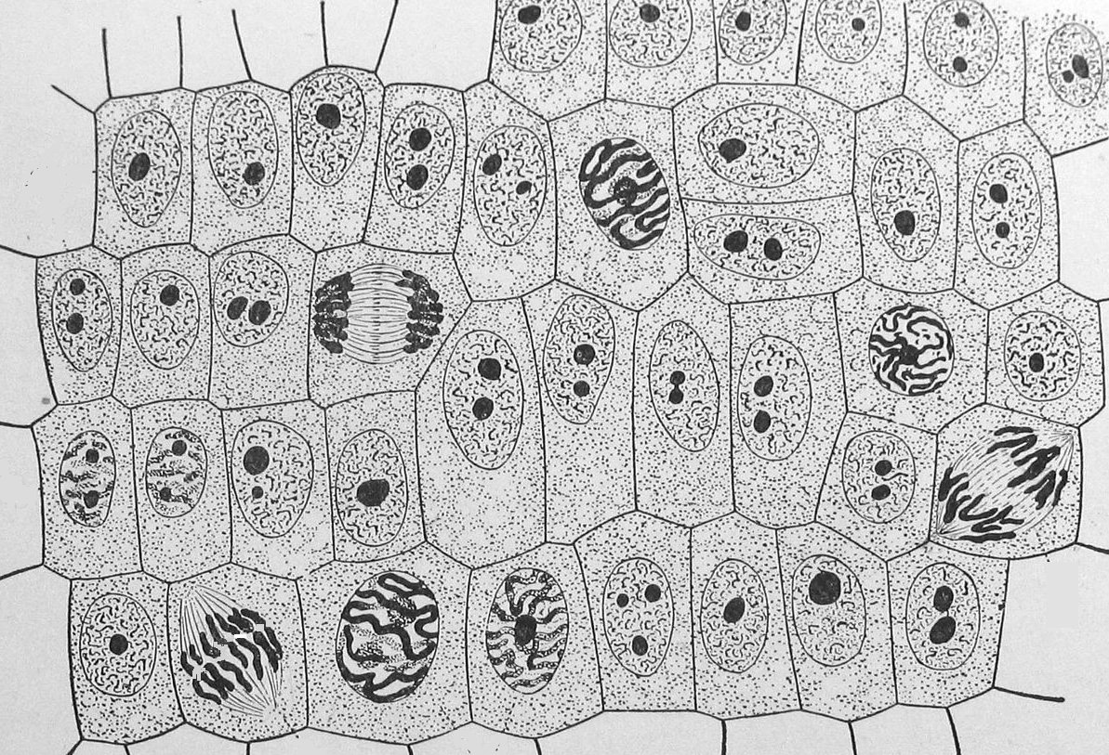
E
A
Identify the stage of mitosis each
lettered plant cell is in:
B
33. | A
34. | B
35. | C
36. | D
37. | E

D
C
F

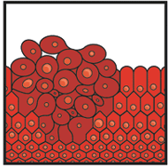
Regulation of the cell cycle
- A mass of cancerous cells is called a t_____________________.
- What is the purpose of checkpoints in the cell cycle?

- What is a carcinogen? ___________________________________________________________________________
Give 2 examples of carcinogens: _________________________ and ____________________________
- Cancer is defined as uncontrolled growth and division of cells due to a failure in the regulation of the cell cycle. Do cancerous cells spend much of their time in G_{o}, the resting period of the cell cycle? Explain why or why not.

Apoptosis Chromosome Develop Grow
Daughter Chromatin Divide Repair

Use the word box below to answer questions 42- 44
- Programmed cell death is called _______________________ and is often trigged by cells that are damaged beyond repair. This process can help protect against cancerous growth.

Big Ideas
- What are reasons EUKARYOTIC cells divide?
- To ____________& ___________________.
- To ______________________ tissue.

- What is the relationship between chromatin and chromosomes?
_____________ is thread-like DNA and is the form usually found in a cell that is not dividing. When a cell is going to divide, chromatin coils up to form a(n) ___________________. Condensing and packaging DNA this way makes it much more manageable and easier to ___________ DNA evenly among the 2 new IDENTICAL ________________ cells.

