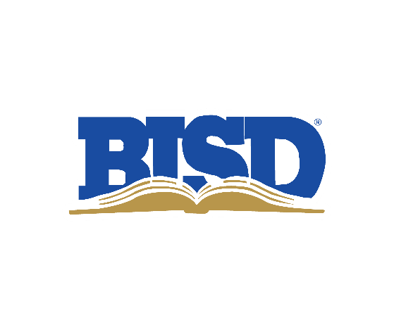

# **2022 Bond Oversight Committee**

# Monday, April 17 | 4:30–5:45 p.m.

# Location: PLC – Blanco/Frio Rooms

**Welcome/Introductions**

**Scope of Work**

Oversight Committee

2022 Bond Highlights

**Appoint Chair/Co-chair**

**Verify contact information**

**Review where we are today**

* Financials/Bond Sale
* Discussion of construction market and strategies employed to reduce construction costs
* Current Projects in Planning
* Technology Update
* Website/Bond questions to [bond22@birdvilleschools.net](mailto:bond22@birdvilleschools.net)
* Groundbreakings
* Mullendore Elementary Groundbreaking
  + Monday, April 17, 9 a.m.
* Smith Elementary Groundbreaking
  + Wednesday, April 19, 9 a.m.

**2023–24 Meeting Dates/Times**

* Monday, April 17 | 4:30–5:45 p.m.
* Monday, July 17 | 4:30–5:45 p.m.
* Monday, Oct. 16 | 4:30–5:45 p.m.
* Tuesday, Jan. 16 (Jan. 15 is MLK Day) | 4:30–5:45 p.m.

**2023–24 Quarterly Reports to the Board – Presentation Dates (Mark)**

* Thursday, April 27 (No Report)
* Thursday, July 27
* Thursday, Oct. 26
* Thursday, Jan. 25, 2024

**Questions/Comments contact:**

Mark Thomas

[mark.thomas@birdvilleschools.net](mailto:mark.thomas@birdvilleschools.net)

817-547-5792 (Office)